Best Data Science CV  
What to consider to make a Data Science resume?

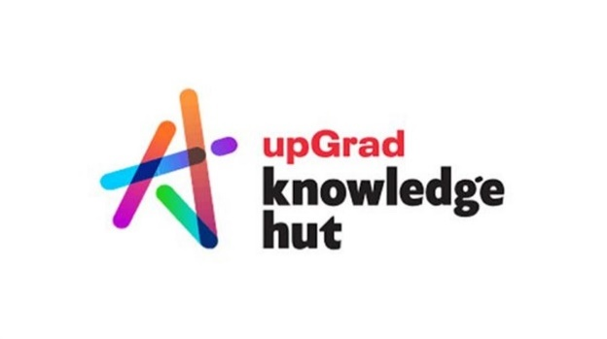

**Anish Mahapatra**

Contents

Introduction 3

How to format a Data Science Resume 3

Sample Data Scientist Resume Template 3

What to include in a Data Scientist Resume 3

Action Work to be included in a Data Scientist Resume 3

Correctly List your Education 3

Data Science Projects and Publications 3

Work Experience 3

Top 15 skills for a Data Scientist Resume 3

Conclusion 3

Author 3

# Introduction

Punch! Duck! Upper Cut!

So, you’ve done the work now – a certification, Bootcamp or course in Data Science and you are ready to take the next step. This can seems like an uphill battle or a fight to the finish. **What do you include in the Data Science resume?** The most potent weapon in your portfolio is the Data Science resume. This article is not a quick stop on your way to resume building. It is a one-stop blog that will help you **answer all your questions end to end**, I promise you. First, you must do the work – read the entire article. Towards the end, if this article did make a difference, do let me know.

Now, how do we go about building a world-class data science resume that is going to help get you interviews? Everyone has a lot of different theories, but I come with the experience of having given over 50+ interviews. My recommendation is to **reverse-engineer** the entire process.

* *How to be in the top 10% of all interviewees for a job?*   
  Understand what the company/recruiter is looking for in the top 10%
* *What skills or keywords you should include in the data science resume?*   
  Understand the keywords that the recruiter is looking for via the job description
* *Why is my Data Science resume not getting selected for interviews?*   
  Understand how resumes get filtered on the recruiter’s or company’s end (we will be talking more about this in the corresponding sections, it’s called ATS!)
* *How to make my resume stand out in the crowd?*Based on the company, role, recruiter and interviewer, you can figure out what design/keywords/approach makes sense to best

There are a bunch of questions to get to, and this will be fun and super helpful. Let’s start by understanding how you can format a resume to give yours an edge!

# How to format a Data Science Resume

The format of a Data Science resume is critical when it comes to making your CV stand out. So what does a Data Science resume format entail, and how does it make a difference? When a recruiter’s average time looking at a resume is [7.4 seconds](https://www.theladders.com/career-advice/you-only-get-6-seconds-of-fame-make-it-count), it is vital to get every detail right. Let’s go over how you can format your Data Science resume:

* **The actual format of the resume**It might seem obvious when reading it in a blog, but I have seen numerous CVs sent out to me in the form of a word document. A not-so-fun fact about Microsoft Word or similar software is that the format can vary depending on the screen resolution, version of the software and even just on different systems. The only way a resume should be sent out is in **pdf format** (unless specifically requested by the company/recruiter).
* **The “About” section of the resume**This is the **elevator pitch** section of the resume. Instead of charting out your goals and how you can be of service to the company, it is advisable to write why you are a strong candidate. The reasoning is that good hiring happens based on how good you are, not what you aspire to be. The about section/profile summary section is the most powerful in the resume and can make a difference.   
    
  It is the first impression the recruiter/hiring manager has about you – make sure it counts!
* **Leveraging listicle and bullet point formats**Paragraphs just do not make sense unless you are writing a book. Look at the style of this article, for instance – one of the many reasons you find it engaging is that you can skim through the blog and still understand the main pointers.For example, look at the paragraph below, which represents a Data Scientist’s experience in a paragraph.   
  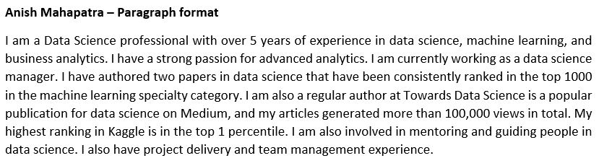It is word heavy and challenging to read. The format can inhibit us from realizing what a good data scientist this person might have been. Let’s analyze the image below to compare how a listicle format and bold text can make a difference. 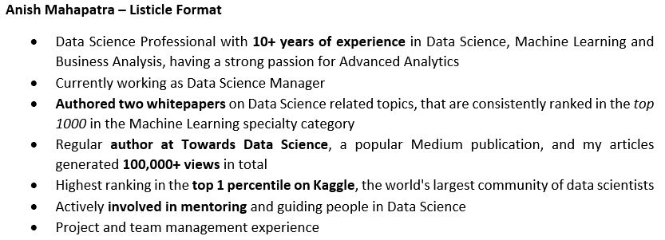A professional resume will be efficiently put across to have the desired impact. Bullet points should not have more than a couple of lines, and the relevant keywords and experience should be highlighted.
* **Text and design formatting consistency**Too many cooks can spoil the broth! Make sure that you are consistent with the following in your resume:
  + Design of the resume
  + Header and sub-header font size
  + Choice of font
  + Spacing between lines and paragraphs
  + Margins from the edge, Alignment and spacing

Remember, the recruiters that go through your resume sift through hundreds, if not thousands of resumes in a week, every detail counts.

* **Grammar and typographical error check!**Nothing screams carelessness more than a typographical error. Use a tool like Grammarly or some online grammar checker to ensure you do not have grammatical mistakes. Catching an error like this can create a subconscious negative impression, and we would definitely like to avoid this.
* **Links to your work**This might take some time to incorporate, but do not fear. It is critical to include links to your work. Following are the platforms I would recommend:
  + LinkedIn – To showcase your professional social network and work
  + GitHub – To showcase your code and portfolio
  + Medium- To showcase your blogs and Data Science articles

A resume is no longer a static document. It is a living representation of how good your profile is. Rather than just including the links, make sure that you hyperlink them!

* **Phone number and email id!**If someone makes an effort to review your resume and wants to get in touch with you for an opportunity, make sure you let them!
  + **Email:** Make sure you have a professional email id and not something that you made in Grade 5 so that there is a positive impression
  + **Phone number:** If you are comfortable, I would definitely recommend sharing your phone number / WhatsApp number as it is the easiest way to reach out

Fantastic! That was quite a detailed section. Good job on getting through it. I hope that was helpful. Let’s now proceed to look at a sample Data Scientist’s resume.

# Sample Data Scientist Resume Template

An excellent way to understand what you can do with your resume is to see other people’s resumes. There is no one size fits all; it would depend on the skills in your resume. However, you are reading this blog to understand industry best practices. Let’s go over some of the sections I would recommend you should include in your resume.

* **Experienced Data Science Resume**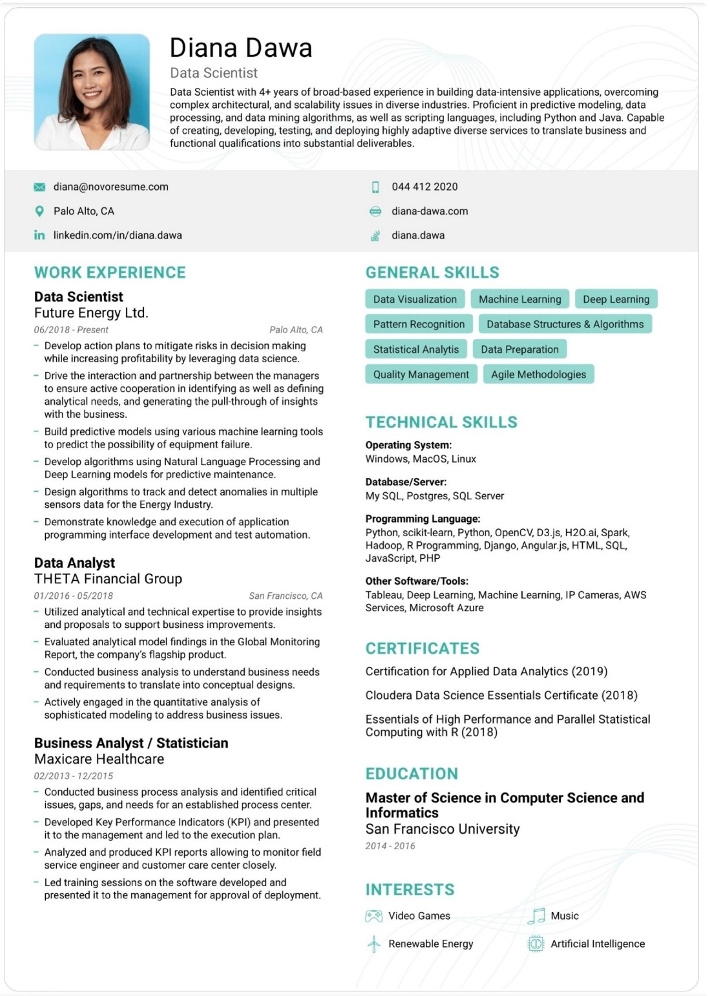  
  ([Source](https://novoresume.com/career-blog/data-scientist-resume))
* **Fresher Data Science Resume**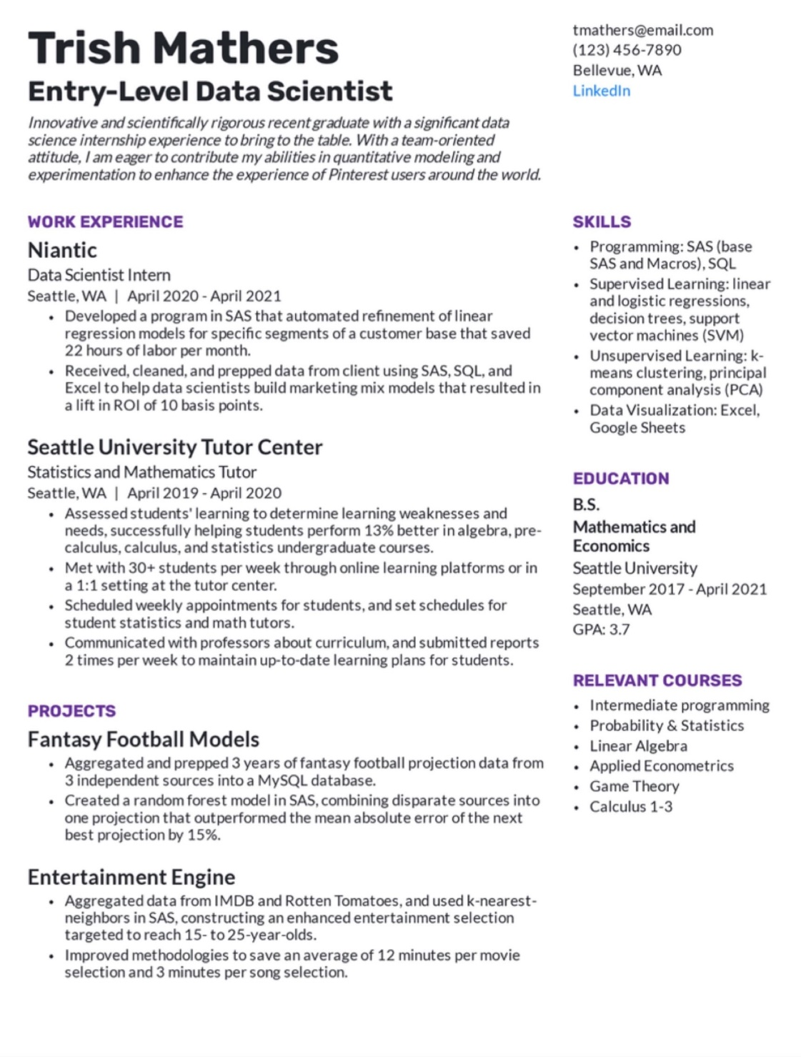  
  ([Source](https://www.beamjobs.com/resumes/data-science-resume-example-guide))

# What to include in a Data Scientist Resume

Remember the introduction? We were discussing what to include in a Data Scientist’s resume. In this section, let’s discuss the areas to have in the outline with the context of Data Science.

* **Profile Summary**The about section or the profile summary section is the most critical part of the resume. It gives the interviewer their first impressions of the candidate and can help them understand if you would be the right fit.
* **Skill Highlights**A section with just keywords of the skills that you would like to highlight to the recruiter is a strong indicator of your research and interest. It is no use to try and shoot an arrow unless you know the target; there is no point in shooting in the dark.   
    
  Similarly, The words to include in the skill highlights would depend on the job description of your target role(s). Sometimes, the skill highlights should be updated depending on the company/job description.
* **Work Experience**List out your *relevant* work experience in chronological order. The **Google X-Y-Z formula** is an excellent format to follow while listing your work experience. The Google X-Y-Z formula states that work experience should be as follows ([Source](https://www.linkedin.com/pulse/20140929001534-24454816-my-personal-formula-for-a-better-resume/))

Accomplished [X] as measured by [Y] by doing [Z]

This potent tool can make a tremendous difference in the representation of your work experience.

* **Education & Certifications**It might be a little controversial, but I firmly believe you should only list your relevant education and certifications. It is alright if you do not have top grades or would not like to disclose everything on your resume. We will discuss this further in a later section below on how to correctly list your education.
* **Extra curricular and achievements**Singing, dancing, racing club in college etc., are some things I still find in Data Science resumes. But, of course, this is not a one-size-fits-all. Still, it should not be there if your extracurricular skill/achievement cannot show some management/data science skills.   
  Extracurricular skills that might be relevant are technical writing, coding, mentoring, helping people, a club management position, etc. So every time you add a line in this section, always take some time and think, what is the value-add here?
* **Referral from LinkedIn**Iam a big fan of LinkedIn referrals. If you have spent the time and effort to get a great referral from someone in a prominent position, adding it at the beginning of your resume is an excellent value addition. Perhaps, a good reference can be my LinkedIn profile, which you can find [here](https://www.linkedin.com/in/anishmahapatra/).
* **Contact Information**Do not forget to add your phone number and email id at the top of your resume. If a recruiter is happy with your resume and wants to take it forward, ensure that your contact information is readily available.
* **Links to professional social media**The resume is a living document that houses all of your best professional work. Ensure that if someone would like to see how you have grown as a person over time, you hyperlink and give them access to your professional social media. This would include LinkedIn, Medium, GitHub, your personal website and so on.
* **Hands-on technical experience**At the rate Data Science is growing, there might be a plethora of things that you can include in this section. I recommend putting it in the following groups for the recruiter’s reference.
  + **Programming Languages:**  Here, you can have all the programming languages and platforms you have worked on.
  + **Tools & Technologies:** Include all of the visualization tools, database tools and enterprise tools that you have worked with
  + **Cloud Platforms:** The obvious choice would be to include the Cloud Platforms you have some experience with. However, you can also include specific modules in case that is relevant to the role you are applying for.
* **For Freshers: Relevant Courses**In case you have no experience in Data Science, a big focus can be the relevant courses you have done from college or websites like Coursera and Udemy.

That covers in detail the sections that you should include in your Data Science

# Action Words to be included in a Data Scientist Resume

Such a great sub-header – “Action words”. These words are what they sound like, powerful words that can give your resume an edge to show that you are an active/proactive person. The case for Data Science leadership would be different. Still, regarding Data Scientists, I believe all of your focus should be on the job description.

All action keywords should be derived from what recruiters are looking for. So, for example, the search would be for **technical action words** to impress rather than action keywords. Let’s go through what recruiters are looking for:

* Programming Languages: Python, SQL, R
* Platforms: Azure Databricks, Jupyter Notebook, JupyterLab
* Tools & Technologies: Power BI, Tableau, Qlik Sense
* Cloud Platforms: Microsoft Azure, Google Cloud Platform, Amazon Web Services

I would recommend you classify technical action keywords based on your target role of data engineer, machine learning engineer, data scientist or business analyst. Each of these roles would have a different set of search criteria for the recruiter and the hiring manager. Focus on how you can contribute and help the company. The more you can contribute, the happier they will be to have you on board!

# Correctly List your Education

Mostly everyone reading this has done their Bachelor’s degree or, at max, their master’s. As you build your profile towards a role in Data Science, try to do the following:

* *Relevant* **Certifications**: Certifications are an excellent way to showcase your area of interest
* *Relevant* **Bootcamps**: Bootcamps can help differentiate you, especially if you do an exciting project that can you can talk about in your interview
* *Relevant* **Degrees**: A degree in Data Science or a relevant field shows your lifelong commitment to the area and can make you stand out in any interview

This can add tremendous value to your profile. One tactic I personally use is if your grades aren’t excellent, or if you do not think something is relevant to Data Science, you can skip it.

# Data Science Projects and Publications

If you do not have relevant experience in Data Science, you need to talk about Data Science. One of the best ways to be a robust Data Science candidate is to have Data Science projects or publications in your name.

*Where do you get Data Science projects from?*

*What are the topics on which you can do data science?*

*Who will teach me Data Science, and what is the fastest way to get into Data Science?*

*How to write and publish a paper for free?*

All of these are some of the exciting questions that we can talk about in our future blogs. So, if they interest you, we can take them up in our future blogs. But, for now, the main takeaway is to have 2-3 excellent projects that you can discuss with the interviewer or recruiter. So, let’s decipher how to structure your work experience in the next section.

# Work Experience

This will be the main point of discussion from the interviewers. As we discussed above, the Google X-Y-Z formula states that work experience should be as follows ([Source](https://www.linkedin.com/pulse/20140929001534-24454816-my-personal-formula-for-a-better-resume/))

Accomplished [X] as measured by [Y] by doing [Z]

Some examples can help you understand what difference this formula can make.

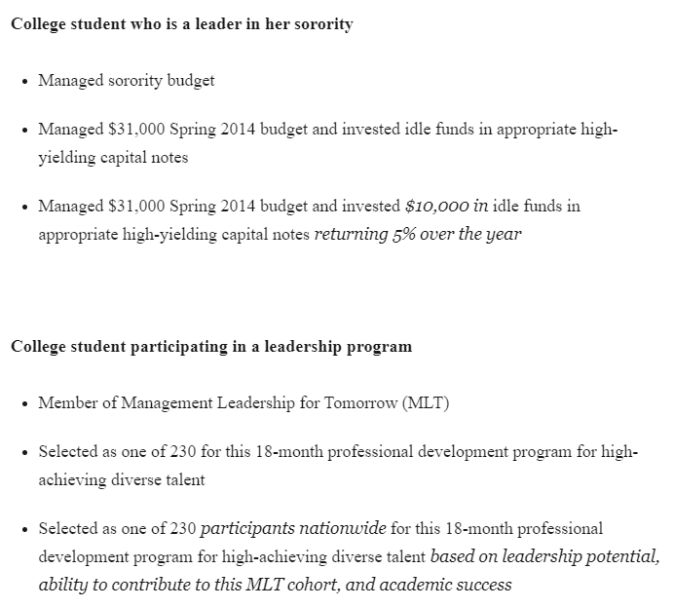

([Source](https://www.linkedin.com/pulse/20140929001534-24454816-my-personal-formula-for-a-better-resume/))

Now, let’s go over the skills we need in Data Science.

# Top 15 skills for a Data Scientist Resume

Alright, based on my experience, here are the top skills that people are looking for in the market:

1. Python
2. SQL
3. PySpark
4. Probability & Statistics
5. Data Science & Machine Learning
6. Algorithms like Linear Regression, Logistic Regression, Decision Tree, Random Forest, Support Vector Machine
7. Visualization tools like Power BI, Tableau
8. Amazon Web Services
9. Azure Databricks
10. Microsoft Azure
11. Google Cloud Platform
12. MLOps (Machine Learning Operationalization)
13. Deep Learning
14. Model Deployment
15. Presentation skills & Stakeholder Management

These are some of the most searched terminologies for Data Scientist resumes.

# Conclusion

Congratulations! You set out with a goal and have managed to diligently read a 3000-word article! You’re a gem and on your way to success. In case you have any doubts or would like to ask me any questions, please feel free to reach out to me via LinkedIn or email. You understood how you can perfect your Data Science resume in this article.

# FAQ

How do I write a CV for data science?

What skills should I put on my resume for data science?

How do you write an objective for a resume for data science?

What are data science goals?

What is the career path of a data scientist?

# Author

**Anish Mahapatra**   
*Senior Data Scientist*   
LinkedIn: https://www.linkedin.com/in/anishmahapatra (LinkedIn)   
Email: anishmahapatra01@gmail.com